Roosevelt Boys Soccer Player Handbook

www.dmrooseveltsoccer.com
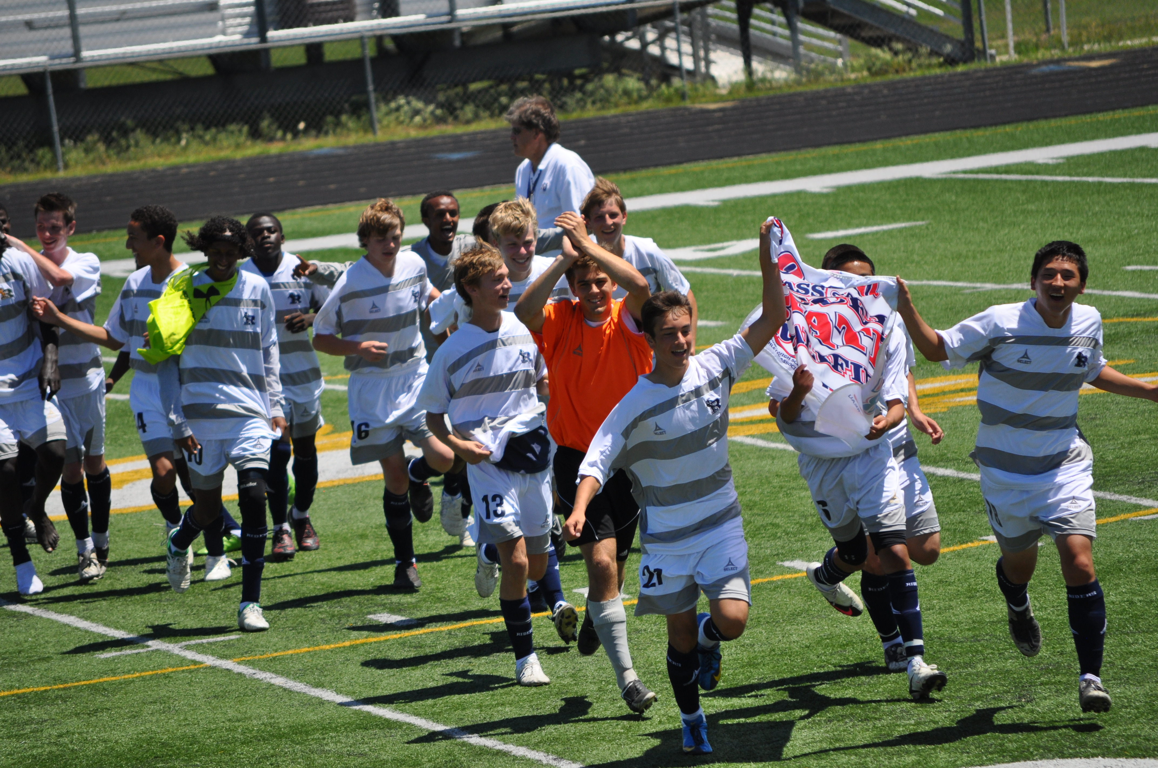

“Far and away, the best prize life has to offer is the chance to work hard at work worth doing.”
-Theodore Roosevelt
(26th President of the US)

My Type of Player….
- Is a complete gentlemen at all times, on and off the field, this means in class, as well as, in the community.
- Hustles at all times… in games and in practice
- Always is looking to improve in all areas of his game
- Knows that referees are human and make mistakes. Therefore, does not focus his energy on criticizing the referees because that can lead to an unfavorable decision later.
- NEVER makes excuses. He realizes he has given his best effort and that there are some things over which he has no control.
- Does not ever give up, even after a bad decision on the field.
- NEVER criticizes a teammate and tries to help the person rather then hurt him. Soccer is a team game and a team is only as strong as its weakest players.
- NEVER underrates an opponent. Any player with a soccer ball at his feet is capable of beating you.
- Is ALWAYS loyal to his team, his school, and his coach. He knows what loyalty is and stands by it.
- Understands that on an entire team, not everyone will be completely happy with all decisions and procedures during the season. He learns that he must adjust to the team situations, not the team to his and will go along with the decisions best for the team.

Do you have the qualities it takes?
Discipline
What is soccer discipline? Soccer discipline is your ability to carry out the rules and regulations of your team. You have to be able to put your talents into the team’s overall plan. Discipline is not easy. However, nothing that is worth getting is ever easy. There are going to be many times when you want to do it your own way, but you cannot always do it your way. Discipline is the key to our success.
Sacrifice
Sacrifice is giving up your time that means a great deal to you, so you can achieve something in another area of life. Can you sacrifice? What sacrifices do you need to make? In today’s society, you have to bend and sacrifice certain things. Sacrifices will come differently to each individual. To be a part of this team, you will have to dedicate yourself to your studies, and then to soccer. Is it easy? No. It is going to be hard not to watch T.V., not to go out on dates, or stay our late with your friends when you have to study or prepare for practice. You will have to sacrifice many things in order for us to win!
Pride
Pride is what we have in our school, in our team, and in ourselves. Pride is working harder in practice than any other team. It is knowing how much sweat and emotion you have given to this team. Pride is not something you get overnight. It is a buildup of your hard work and dedication to me, you and, most importantly, this team.
I will work harder then any other coach and I expect you to work harder than every other team. I have pride in our uniforms and practice equipment, and I expect you to have it also. I am proud to represent Roosevelt High School and you should too. Pride should flow through your veins and be evident in our attitude towards this school and this soccer program. Many of came before you and set a standard of excellence, it is your job to keep it going.
Responsibility
What are you responsible to? First, you are responsible to your faith, family, and your studies. After that, you are responsible to this team. You are responsible for carrying out the qualities of this team. Every time you step out on the field, you are being judged by your peers, faculty, and the pubic. You are responsible for representing this soccer program in a FIRST-CLASS manner at all times. Although you may not realize it, people look up to you in many ways. They wish they had the athletic talent you have, and the ability to dedicate, sacrifice, and have pride in what you do.
Mental Toughness
Mental toughness is the key to winning and losing. It is the ability to shut everything out, but the task at hand. Mental toughness is the ability to play under severe conditions. Can you play hurt? Can you concentrate and overcome when you are tired? Can you hold your head up when a referee calls a foul on you, when you know it was a foul you did not commit. Yes you can!! You have to overcome the little things of the game that turn out to be the “big thing”. Do not let you opponent know you are hurt or tired. Do not let your opponent know he is bothering you. This is mental toughness. If you can control yourself through mental toughness, you can become a winner.
“ I care not how hard you can hit, I care more about how hard you can get hit and get back up!”
General Procedures for the Season
The following outline summarizes our policies concerning the soccer season:
Academics
- Academics always come before soccer! Your first priority here is your studies- that is why you are here.
- You will be expected to handle your studies in a first class manner. If you loaf in the classroom, you will probably loaf on the soccer field. There is no place in our program or society, for a loafer.
- Budget your time- it is not acceptable to blow off your studies because of soccer.
- If you miss some of practice because of school you should bring a note. You should also try to schedule help after school on game days, during your lunch, or during your free periods. Use your nights and weekends wisely so you are not having to miss practice for not being scholastically prepared.
Eligibility
- According to the policy set forth by the IHSAA, students who receive a semester grade of an “F” for any class, must sit out 30 calendar days.
- Academic ineligibility is just ground for dismissal from the team. If during grade checks, you let your grades slip below a C, you may not play until they are up.
- The coaching staff may dismiss a player at any time if they feel that the athlete is not an asset to the team, or the athlete does not follow team rules.
- Additionally, head coaches at their various levels may implement their own policies regarding academics.
Attendance
- ABSENCE FROM PRACTICES, GAMES, OR OTHER TEAM FUNCTIONS WILL NOT BE TOLERATED! The only absences that will be deemed as excused are: family emergency, academic reasons, or illness. It is imperative that if you are going to miss for any of the above reasons, you notify me not later than noon of that day. Although these are deemed as “excused” absences, they will not go without penalty. Whether you are sick or making up a test with a teacher, one of your teammates was there working to get better and will be rewarded by moving up in the rotation. In most cases, a player may not start or be withheld from competition time because of an excused absence.
- Essentially, any absence not mentioned above will be deemed as an unexcused absence. Going to work or not being able to find a ride are not acceptable reasons for not attending. You also should schedule medical and dental appointments around school and soccer schedule. Penalties for unexcused absences are as follows:
1st Unexcused Absence- withheld from ½ of competition
2nd Unexcused Absence- withheld from next competition
3rd Unexcused Absence- Indefinite suspension from competition
4th Unexcused Absence- Dismissal from team
- PROMPTNESS is a must! You will be expected to be on time to practices, games, or other team functions. Consequences for tardiness will be mostly, but no limited to, additional conditioning for the team or individual. Excessive tardiness may lead to dismissal from the team.
Behavior/Citizenship
- Model citizenship is expected at all times- both on and off the field! As a student-athlete, your behavior is magnified much more than the rest of the student body. You must conduct yourself in a first-class manner in the classroom, hallways, cafeteria, on the soccer field, or in the community.
- The coach may dismiss a player at any time if he feels they are not conducting themselves in a first-class manner.
Attitude
- Players are expected to develop and maintain a positive attitude when it comes to this team. We only have each other so we much spend our time building ourselves up not tearing ourselves down. There is enough negativity in the world. Negativity is a cancer that spreads. As soon as you think something cant or won’t happen, it probably won’t. When you are around your teammates the expectation is for you to have a positive attitude. Everyone has value whether you are a starter, 2nd string, manager, or asst
- Quarreling, bickering, jealousies will not be tolerated. We must work, sacrifice and WIN together.
- We are not interested in selfish players. We want guys who play for ROOSEVELT! If your top priority is not how you can help our team be successful, then this is not the program for you.
Games
- Boys will report to the field one hour prior to the start of the game. They will have 20 minutes to get ready as a team. Headphones are permitted at this time. The players will be ready to warm-up 40 minutes prior to the start of the game.
- Dress- Home or away games, boys are to dress up. No Jeans or tennis shoes are permitted. Boys will be expected to wear the assigned (polo or warm-up) this to school the day of a game. Failure to follow this dress policy will result in not dressing for the contest.
- All players are required to ride the bus to the away games that require one. The only exceptions to this is if your parents or guardians request in writing that you ride home from the game with them.
- Come ready to play with a business-minded approach. You must prepare yourself mentally throughout the week with game days as the climax. We are here to COMPETE and WIN, every game!
- All players are required for taking their own equipment to the games and ensuring it gets in the proper place after a game. Lost or stolen uniforms must be paid for by the athlete it was issued to.
- There will be a meeting after every game. Players will remained dressed and will not take off any equipment before the end of this meeting.
- BENCH CONDUCT- Everyone is expected to be watching the game! Whether you are normally the first guy off the bench or the last, you must always be focused on the game. You never know when you will be called upon. If you are asked to go in for someone, you should know where they are playing.

IF YOU WISH TO SIT ON OUR BENCH YOU WILL
- Communicate only with teammates or coaches- not the crowd
- Never will any sort of electronic device (cell phone, Ipod, etc.) accompany you to the bench
- Stand and Huddle around the coach, before, after and at halftime. Give eye contact to your coaches at this time.

- No one will talk to the officials other then the coach and the captain, and he will do so only in a polite manner. There will be no questioning of officials decisions by my players.
9. Prior to a contest, go home after school and rest! In order to give maximum effort your body should be rested as possible. Hydration is also very important during this time. Drink plenty of water and/or Gatorade prior to a contest.
ROOSEVELT BOYS SOCCER PRACTICE RULES

- Attendance and promptness are mandatory! Be here and be on time! If you are on time you are 5 minutes late.
- Be ready to work. We only have so many hours at practice and they are not going to be wasted.
- Be ‘team’ oriented. Do not put yourself ahead of the team.
- Have and maintain a positive attitude at all times. We will not tolerate individuals with poor attitudes. If you do not want to be there go home. Do not forget there is always someone wanting to take your spot!
- Hustle and play hard all the time! The only time you may sit down or get a drink is with the coaches permission.
- No horseplay will be allowed- Be focused on IMPROVEMENT at all times.
- Learn to accept criticism- It’s purpose is to make you a better player and us a better team.
- Practice gear is to be worn at all practices. Blue or white shirt. Shin guards are to be worn at every practice. $1 will be charged to get back anything you leave behind.
- Absolutely no swearing! We practice at schools and near parks. We have young family members around practice, in the stands, and in the parking lot. You hurt the team if you do it in a game. Consequences will be administered for this lack of discipline.
- I respect our equipment and I expect the same from you. Cones are not to be smashed or kicked. Practice balls are not to be sat on.

TRAINING/ NUTRTITION

Soccer is a long season, and in order for you to reach maximum potential game in and game out, you must take care of your body. The things listed below and many others not listed should be self-imposed rules.
- No Smoking
- No use of illegal drugs or alcohol- If you are in a situation where either of these might be present, LEAVE. There is always suspicion of guilt by association.
- Get your rest and try to keep regular sleeping hours. You should get a minimum of 8 hours of sleep a night.
- Keep your body hydrated- as in-season athletes, you should be consuming at least 64 oz. of water and/or Gatorade daily. DO NOT DRINK SODA DURING THE SOCCER SEASON!
- Maintain a healthy diet. Eat plenty of fruits and vegetables.
- Avoid eating rich, greasy foods the day of the game. Easily digested foods such as loose meat sandwiches, bagels, granola bars, and fruits/vegetables should be consumed on game day. Eat a pre-game meal roughly 3-4 hours prior to a contest.
- Develop a game day routine that includes hydration, meals and meal times, and get plenty of rest!
- Stay home and rest both two nights, and the night before a game. You should be in bed no later than 10PM on these nights.

Parents and players
Please sign and return this sheet to verify that you have received your copy of the parent and player handbooks. By signing, you also acknowledge that you have read the information, understand it, and agree to abide by the criteria set forth for the duration of you participation in the Roosevelt Boys Soccer Program.

_____________________________________________ ________________________________________
Player Name Parent Name

_____________________________________________ ________________________________________
Player Signature Parent Signature

_____________________________________________ ________________________________________
Date Date

Return only this sheet signed

